
Student Performance United States
Can students’ academic performance be accurately predicted based upon a student’s demographics, study habits, parental involvement and extracurricular activities.


Introduction
The aim of this report is to predict whether a student will receive a ‘Good’ GPA based on a number of predictors. I will be processing and analysing data taken from the data set "📚 Students Performance Dataset 📚" by [Rabie El Kharoua], licensed under CC-BY 4.0 https://creativecommons.org/licenses/by/4.0/.
DOI citation: Rabie El Kharoua. (2024). 📚 Students Performance Dataset 📚 [Data set]. Kaggle. https://doi.org/10.34740/KAGGLE/DS/5195702

The data set contains 2392 rows and 15 columns. The columns are as follows StudentID, Age, Gender, Ethnicity, ParentalEducation, StudyTimeWeekly, Absences, Tutoring, ParentalSupport, Extracurricular, Sports, Music, Volunteering, GPA and GradeClass.
After conducting a data quality check, I found no missing values and no repeated rows. I had found all entries to be within their expected ranges, and no class to have little to no entries. Furthermore, there was no outliers for the numerical variables. I did however find 168 rows where GPA and GradeClass did not align. I decided it best to remove said rows, as I had no way of knowing what the correct input was.
For this project I decided to focus on the following 12 variables: Gender, Ethnicity, ParentalEducation, StudyTimeWeekly, Absences, Tutoring, ParentalSupport, Extracurricular, Sports, Music, Volunteering and GradeClass. My response variable will be GradeClass. This has been converted to a binary variable, in which those students who have a ‘Good GPA’ have been assigned 1 while those who do not have been assigned 0. The original data set also has categorical variables denoted by numbers 0 through to some n, I converted these to characters to reduce any potential coding problems that may arise.
For the sake of this project a ‘Good’ GPA is a GPA considered to be above or equal to 3.0, this is equivalent to a grade B. This grade is the minimum requirement for many Masters.

The main objective of this report is to determine whether a student’s academic performance can be predicted using data regarding the student’s demographics, study habits, parental involvement and extracurricular activities. This report will also compare different classification models, as chosen by me, in order to determine which modelling approach performs best for this data set in terms of predictive performance.

This report is intended to be read alongside the relevant code.

This report will be broken down into 6 Sections:
- Exploratory Data Analysis
- Model 1: GLM
- Model 2: Deep learning
- Model 3: SVM
- Model 4: Random Forest
- Comparing the models and Conclusion

The clean data set contains 2224 rows and 12 columns; each rows represents a student and each column is a variable as follows:
- GradeClass: Classification of students’ grades based on GPA:
Binary - 0: GPA < 3.0, 1: GPA >= 3.0
- Gender: Gender of the student:
Binary - Male, Female.
- Ethnicity: Ethnicity of the student:
Character – ‘A’, ‘B’, ‘C’, ‘D’
A: Caucasian
B: African American
C: Asian
D: Other
- ParentalEducation: The Education level of the parents of the student:
Character – ‘A’, ‘B’, ‘C’, ‘D’, ‘E’
A: None
B: High School
C: Some College
D: Bachelor’s
E: Higher
- StudyTimeWeekly: How many hours a week the student studies, in hours:
- Numerical – Range 0 to 20
- Absences: The number of absences the student has during the school year:
- Numerical – Range 0 to 30
- Tutoring: Whether a student receives tutoring:
Binary – No, Yes
- ParentalSupport: Level of parental support a student has:
Character – ‘A’, ‘B’, ’C’, ’D’, ’E’
A: None
B: Low
C: Moderate
D: High
E: Very High
- Extracurricular: Whether a student participates in extracurricular activities:
Binary – No, Yes
- Sports: Whether a student participates in sports:
Binary – No, Yes
- Music: Whether a student participates in music activities:
Binary – No, Yes
- Volunteering: Whether a student participates in volunteering:
Binary – No, Yes
Limitations
- The data set is synthetic, meaning it may not accurately represent real-world students.
- Some classes within categories have less entries than others, this may potentially lead to bias prediction and reduced accuracy for minority classes.
- The removing of the 168 rows where GradeClass and GPA has reduced my sample size and may potentially lead to bias and affect model estimates.
- The decision to split GradeClass into a binary variable has amplified the already existing class imbalance for this variable. This will potentially impact the performance of my models and will need to be considered in their evaluation.
- The decision to remove Age as a predictor, means the potential impact it may have had on student’s academic performance was not captured in my final models. This decision was made as the range was small and I wished to focus on all students in high school as a whole and not have them defined by age.

Exploratory Data Analysis
Data Overview
After cleaning we remain with 2224 rows and 12 columns. Each row represents a student, and each column represents a variable. 11 of these variables will be our predictor variables.
Univariate Analysis
The response variable, GradeClass, has a large class imbalance with 86.5% of students within the data set having a GPA below 3.0 and the remaining 13.5% students having their GPA above or equal to 3.0. This suggests that is highly more probable for a student to receive a GPA below 3.0 rather than above or equal to.
There are two numerical predictors, StudyTimeWeekly and Absences. These were examined using summary of the values and visualized using a histogram. StudyTimeWeekly ranges from 0 to roughly 20, with a mean of 9.79 and a median of 9.72. Absences ranges from 0 to 29 with a mean of 14.55 and a median of 15. Both of their histograms suggest a relevantly even distribution across the range, with similar frequencies across the board.
The categorical predictors, Gender, Ethnicity, ParentalEducation, Tutoring, ParentalSupport, Extracurricular, Sports, Music and Volunteering were examined using frequency tables which included both the count and percentage and visualized using bar charts. Across the predictors there are varying levels of class imbalance with Gender having a near 50/50 split, meanwhile volunteering has a near 85/15 split. Despite this no class had little to no data, suggesting they are still suitable for modelling.
Bivariate Analysis
The first type of bivariate analysis conducted was comparing the response variable to a predictor. This was conducted using contingency tables, probability tables, box plots and logistic regression model with only one independent variable.
Gender – From the probability table it can be summarized that Gender has little to no influence on whether a student receives a ‘Good’ GPA or not, with both showing that the percentage of students who do receive a ‘Good’ GPA is around 13%. This is further backed up by the logistic regression, which shows a p-value of 0.786 indicating Gender is not a statistically significant predictor of GradeClass.
Ethnicity – From the probability table it can be summarized that similarly to Gender, Ethnicity has little to no influence on whether a student receives a ‘Good’ GPA. For all four different options the probability of a ‘Good’ GPA range from 12.7% to 15.3%. This is again confirmed by the logistic regression, which shows p-values of 0.170, 0.566 and 0.830 all suggesting there is no significant statistical evidence that ethnicity is a predictor of GradeClass.

Parental Education – From the probability table we can see that the percentage of students whose parent education is classed as higher and who have ‘Good’ GPA is 9% this is slightly lower than the others who sit around 12.8% to 14.1%. However, from the logistic regression we can see that there is no significant statistical evidence that Parental Education is associated with grade class, with p-values of 0.717, 0.618, 0.917 and 0.350.
StudyTimeWeekly – From the box plot, we can visually see that students who study more are more likely to get a ‘Good’ GPA, students who got a GPA below 3.0 have a median study time of roughly 9 hours a week and a range of around 4 to 14. Meanwhile students who did achieve a GPA higher than or equal to 3.0 have a median study time of roughly 12 hours a week and a range of around 8 hours to 16 hours. This is further backed up by the logistic regression, the coefficient for StudyTimeWeekly (Estimate) has a value of 0.073 when converted to odds ratio we find that for every extra hour a student studies the odds of them achieving a ‘Good’ GPA increases by 7.6% (The odd ratio value is 1.076). StudyTimeWeekly has a p-value of 1.24e-10 meaning the association between StudyTimeWeekly and GradeClass is statistically significant.
Absences – From the box plot it can be deduced that students who have less absences are more likely to get a ‘Good’ GPA, students who have a GPA less than 3.0 have a median of roughly 17 absences while students who are above or equal to have a median of absence of roughly 2 absences. This is further supported by the logistic regression; there is a coefficient of -0.485. In odds ratio this means for every extra absence a student has the odds of them achieving a ‘Good’ GPA decrease by 38.4% (The odd ratio value is 0.61598). Absences have a p-value of <2e-16 meaning the association between Absences and GradeClass is statistically significant.
Tutoring – From the probability table it can be summarized that tutoring does have an impact on GradeClass, the percentage of those who did achieve a ‘Good’ GPA is 10.3% for those who did not receive tutoring as opposed to 20.8% who did. Via the logistic regression we get that the estimate for TutoringYes is 0.828, in odd ratios this means students who do receive tutoring are 2.289 times more likely to achieve a ‘Good’ GPA compared to those who don’t. The p-value for TutoringYes is 5.74e-11 meaning the association between Tutoring and GradeClass is statistically significant.
ParentalSupport – The probability table for ParentalSupport shows varying percentages of those who achieved a ‘Good’ GPA with percentages as low as 3.6% to as high as 19.7%. The logistic regression shows that ParentalSupport is a statistically significant predictor for GradeClass with all p-values sitting below 0.05 and all but one sitting below 0.001. The Estimate’s suggest that as the level of ParentalSupport increases so does the odds of a student achieving a ‘Good’ GPA, relative to ParentalSupportA, None. With odds ratios ranging from 2.57 at Level B to 6.64 at Level E.
Extracurricular – The probability table shows the percentage of those who achieve a ‘Good’ GPA is higher at 16.4% for those who do participate in extracurricular activities as opposed to those who don’t at 11.6%. The logistic regression table shows an Estimate value of 0.40067 for ExtracurricularYes, which when converted to odds ratio means that students who do participate in extracurricular activities are 1.49 times more likely to achieve a Good ‘GPA’ compared to those who don’t. Furthermore, there is a p-value of 0.00134 meaning that Extracurricular is a statistically significant predictor for GradeClass.
Sports – From the probability table it can be summarized that sports do have a slight influence on a student’s academic performance, the percentage of students who do achieve a ‘Good’ GPA who do participate in sports is 16.6% but for those who don’t participate in sports the percentage is 12.1%. The logistic regression suggests that Sports is a statistically significant predictor for GradeClass with a p-value of 0.00456, the Estimate for SportsYes is 0.3673 meaning a student who does participate in sports is 1.44 times more likely to achieve a ‘Good’ GPA than those who don’t.
Music – Just like with Sports and Extracurricular the percentage of students who achieved a ‘Good’ GPA who participated in music activities is higher than those who did not at 17.9% and 12.4% respectively. The Estimate coefficient for MusicYes is 0.43692 which means that students who participate in music activities have 1.55 times higher odds of achieving ‘Good’ GPA, relative to those who do not. There is also a p-value of 0.00223 meaning Music is a statistically significant predictor of GradeClass.
Volunteering – From the probability table it can be summarized that whether a student volunteers or not has little to no impact on if the student achieves a ‘Good’ GPA with very close percentages of 14.1% and 12.4%. This is further backed up by the logistic regression, which shows a p-value of 0.725 meaning that there is no statistically significant evidence that Volunteering is associated with GradeClass.

The second type of bivariate analysis conducted was comparing a predictor to a different predictor. This is to check for any relationships and associations between the two, as such relationships may lead to confounding. This was conducted using chi-square tests, logistic regressions, Kruskal-Wallis tests, and correlation matrices.
Most predictors showed no statistically significant association, however there are four occurrences when it did occur these are also follows; ParentalEducation and Music, this received a chi-squared p-value of 0.0185, Tutoring and Volunteering, this received a chi-squared p-value of 0.0125, Tutoring and StudyTimeWeekly, this received a logistic regression p-value of 0.0499, Absences and Volunteering, this received a logistic regression p-value of 0.0277. Tutoring and StudyTimeWeekly is bordering on 0.05 meaning it is borderline significant so there is little to worry about, the other 3 while being more statistically significant are still fairly weak with no p-value sitting below 0.001, meaning the effects should be weak and should present no significant multicollinearity problems.

Multivariate Analysis
A logistic regression model with all variables included was fit in order to understand how the variables behave. There were slight changes to both Estimates and P-values which will need to be considered.

Model 1: GLM
The first model fitted was a logistic regression model. A logistic model is interpretable and simple and will allow us to investigate how each of the predictors affect GradeClass.
A logistic model with all predictors was fitted first, this model tells us that the statistically significant predictors are StudyTimeWeekly, Absences, Tutoring, ParentalSupport, Extracurricular, Sports and Music. Each affecting the odds of achieving a ‘Good’ GPA differently. Due to the number of predictors and the chance for confounding and redundancy it was deemed necessary to do some variable selection.
Stepwise selection was conducted using both AIC criterion and BIC criterion, the aim of which is to find two models with the lowest AIC/BIC respectively. The model with the lowest AIC only contained the predictors Gender, StudyTimeWeekly, Absences, Tutoring, ParentalSupport, Extracurricular, Sports and Music. All these predictors apart from Gender have a p-value of below 0.001, while Gender has a p-value of 0.068. The model with the lowest BIC only contained the predictors StudyTimeWeekly, Absences, Tutoring, ParentalSupport, Extracurricular, Sports and Music. Not including Gender these results match with what was found during the EDA.
Lasso and Ridge regression was also used to assess variable importance as well as assess potential multicollinearity. Both Lasso and Ridge shrink coefficients towards zero, but while Ridge regression keeps all predictors, Lasso regression can force some coefficients to be exactly zero. Cross-validation was performed using a training set for both in order to find a good value for λ, this was found to be 0.000689 and 0.0183 respectively. The predictive accuracy for the two was found using the testing set, these were 0.96 and 0.94 respectively suggesting lasso has better predictive accuracy. Ridge was not used in the final model due to it not being able to select variables, unlike Lasso, which was used to help determine which variables to keep in.
The variables which Lasso did not remove align with those selected by AIC and BIC, providing strong evidence that these predictors have high influentially when it comes to academic performance. A final model was fitted using these chosen predictors as follows; StudyTimeWeekly, Absences, Tutoring, ParentalSupport, Extracurricular, Sports and Music. The summary of the final model tells us the following:
- All p-values sit below 0.05 with, all but ParentalSupportB sitting below 0.01, meaning all predictors have a statistically significant association to GradeClass.
- StudyTimeWeekly has an Estimate coefficient of 0.270. By converting to odds ratio, we find that for each additional hour of study the odds of a student getting a ‘Good’ GPA increases by 30.9%. (The odd ratio value is 1.309).
- Absences have an Estimate coefficient of -0.954. By converting to odds ratio, we find that every absence a student has the odds of that student getting a ‘Good’ GPA decreases by 61.5% (The odd ratio value is 0.3851).
- TutoringYes has an Estimate coefficient of 2.57. By converting to odds ratio, we find that students who receive tutoring have 13.07 times higher odds of getting a ‘Good’ GPA compared to those who don’t.
- ParentalSupportB has an Estimate coefficient of 2.35. By converting to odds ratio, we find that students who have low parental support have 10.51 times higher odds of getting a ‘Good’ GPA compared to those with none.
- ParentalSupportC has an Estimate coefficient of 3.61. By converting to odds ratio, we find that students who have moderate parental support have 37.1 times higher odds of getting a ‘Good’ GPA compared to those with none.
- ParentalSupportD has an Estimate coefficient of 4.95. By converting to odds ratio, we find that students who have high parental support have 141.5 times higher odds of getting a ‘Good’ GPA compared to those with none. This result needs to be taken with caution as the high value is likely a result of class imbalance.
- ParentalSupportE has an Estimate coefficient of 6.17. By converting to odds ratio, we find that students who have very high parental support have 480.2 times higher odds of getting a ‘Good’ GPA compared to those with none. This result needs to be taken with caution as the high value is likely a result of class imbalance.
- ExtracurricularYes has an Estimate coefficient of 1.786. By converting to odds ratio, we find that students who participate in extracurricular activities have 5.97 times higher odds of getting a ‘Good’ GPA compared to those who don’t.
- SportsYes has an Estimate coefficient of 2.413. By converting to odds ratio, we find that students who participate in sports have 11.17 times higher odds of getting a ‘Good’ GPA compared to those who don’t.
- MusicYes has an Estimate coefficient of 1.599. By converting to odds ratio, we find that students who participate in musical activities have 4.95 times higher odds of getting a ‘Good’ GPA compared to those who don’t.
Due to the large number of predictors, a visualisation of all the possible scenarios was unable to be made to visualise the above results.
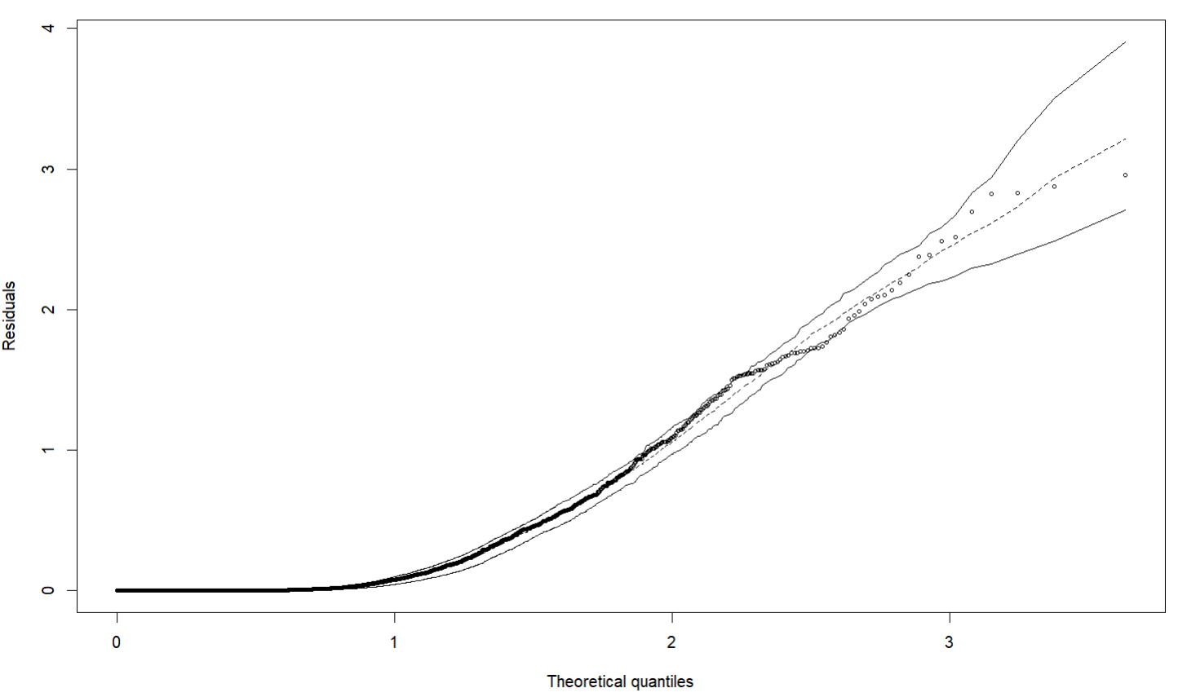
A residual plot was also made for the final model, to check the fit of the model.

Since almost all points sit within the envelope band, the model could be said to fit the model well.

Model 2: Deep Learning
The second model fitted was a neural network. Neural networks excel at finding complex patterns and non-linear relationships but are less interpretable than logistic regression models with no ability to analyse predictors individually.
Before fitting the neural network, all predictor values were converted into a standardised numeric design matrix. The data set was then split into a training set and a testing set, using a 2-1 split using a random fixed seed.
To fit the neural network for the data set, a model structure is first set up which describes the network. This consists of a hidden layer with 16 units and ReLU activation function with the initial input of all predictor variables, a drop out layer with a rate of 0.4 and output layer with one unit. The structure has been made to be suitable for binary classification. 16 units and a dropout rate of 0.4 were chosen based upon my data set. 16 units were chosen as my data has 2224 rows and 11 predictors this will allow the model to be flexible enough to capture non-linear relationships but small enough to avoid overfitting, a dropout rate of 0.4 was chosen as my data set is imbalanced and it can help to reduce overfitting without underfitting.
Next up details are added to the model which control the fitting algorithm, the model was compiled using binary cross entropy loss, RMSprop optimizer and performance metric binary accuracy. These were chosen as they are appropriate for a binary classification problem. The model was then fit as a history object using the training data and the fitting parameters epochs and batch size, a validation data set was supplied to avoid the model using the testing data during fitting. 300 epochs was chosen to allow the model to converge and a batch size of 32 was chosen as it provides a good balance between flexibility and stability.
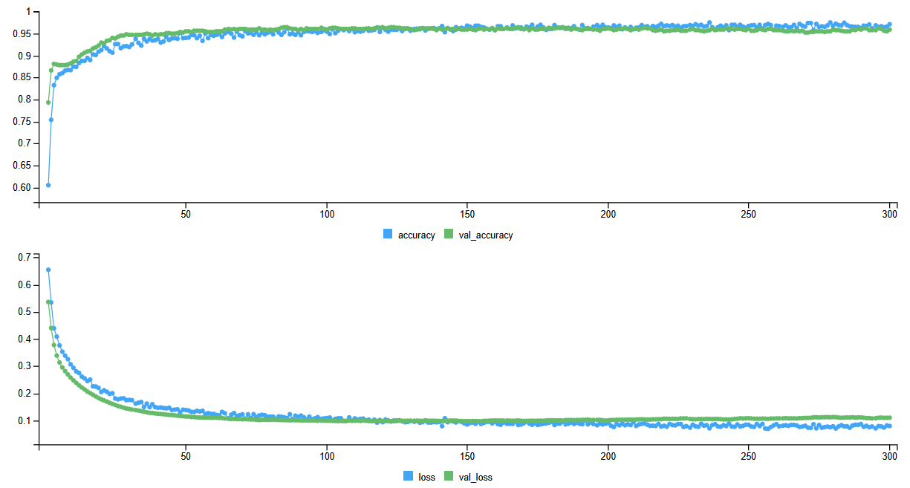
The history has been plotted to display the accuracy for the training and testing data.
The graph shows a plot for accuracy against epochs at the top, and a plot for loss against epochs at the bottom. The blue line representing the training data and the green line represents the validation data in this case out testing data. From the graph we can see both training accuracy and testing accuracy rises rapidly and plateaus at about 0.95, this suggests the model learns quickly, performs well on unseen data and has no signs of overfitting. We can also see that both loss and validation loss sharply drop early and plateau at around 0.1, testing loss stays below training loss and training continues, this suggests the model is learning and converges smoothly with no signs of overfitting. This training history suggests that the neural network is working well and is appropriate for this data set.
The neural network is then used to predict the outcome of the test data, and its performance evaluated. The test accuracy of the model is 95.95%, meaning the majority of students were correctly classified. This indicates that the model has strong predictive performance, however due to the class imbalance this accuracy must be interpreted with caution. This will be considered when comparing the models.

Model 3: SVM
The third model fitted was a Support Vector Machine. Support Vector Machines excel in high-dimensional spaces, they can learn non-linear relationships and aim to find the best boundary by maximising the margin, this also means they are robust to overfitting.
Before fitting the support vector machine, all predictor values were converted into a standardised numeric design matrix. The data set was then split into a training set and a testing set, using a 1-1 split using a random fixed seed.
The training data is then fit onto a baseline support vector machine, with a radial kernel, γ equal to 1 over the number of predictors and cost equal to the 1. Radial kernel allows the SVM to learn non-linear relationships and non-linear boundaries, this is important for the dataset as we already saw non-linear relationships in the EDA. Both cost equal to 1 and gamma equal to 1 over the number of predictors is a good baseline for an SVM. The model was then summarized, and the following results were found: 261 out of the 1112 observations from the training data are support vectors, meaning they are the observations closest to the decision boundary and the points which define the classifier. 136 out of these 261 are from class 0 and the remaining 125 are from class 1, these numbers suggest that the classes have a moderate margin with a stable boundary, and the model is not too complex. The training accuracy was then found for the trained SVM, this value is 0.9595.
A cross-validation was then performed to find the best choice of γ and cost for SVM with a radial kernel, this was performed using tune with a list of 5 potential costs and 5 potential gammas. The tuning procedure compared 25 combinations, the aim of which is to find the parameters which result in the lowest testing error. The best parameters are found to be, cost =100 and gamma = 0.01. The testing accuracy was then found for the best tuned SVM, this value is 0.9559. This indicates that the model has strong predictive performance, however similarly to before, due to the class imbalance this accuracy must be interpreted with caution. This will be considered when comparing the models.

Model 4: Random Forest
The fourth model fitted was a Random Forest. Random Forests are able to handle non-linear relationships, are good for mixed data types/complex data and are robust to overfitting.
Before fitting the random forest. The data set was then split into a training set and a testing set, using a 1-1 split using a random fixed seed.
The training data is then fit onto a classification random forest. Mtry tells the model how many predictors should be considered for each split. For a random forest of classification trees, the mtry value should be equal to √p where p is the number of predictors, the dataset contains 11 predictors so mtry is set to 3. The testing accuracy is 0.9496 indicating that the model has strong predictive performance, this however must be interpreted with caution due to the class imbalance. This will be considered when comparing the models.
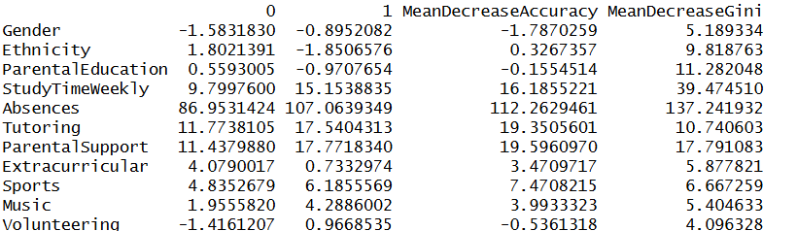
The importance function was used to view the importance of each variable. Two measures of importance were reported: mean decrease in accuracy and the mean decrease in Gini.

MeanDecreaseAccuracy tells us that how important each variable is, variables with a large positive MeanDecreaseAccuracy such as Absences are very important, variables with a near zero MeanDecreaseAccuracy, like Ethnicity, have little importance and variables with a negative MeanDecreaseAccuracy, such as Gender, may be adding noise and are not useful. MeanDecreaseGini tells us how influential a variable is in tree splitting. Absences have a MeanDecreaseGini of 137.24 meaning it is the dominant predictor. The larger the value is the more influential the predictor is in tree splitting.
These important measures can be visualized as follows.
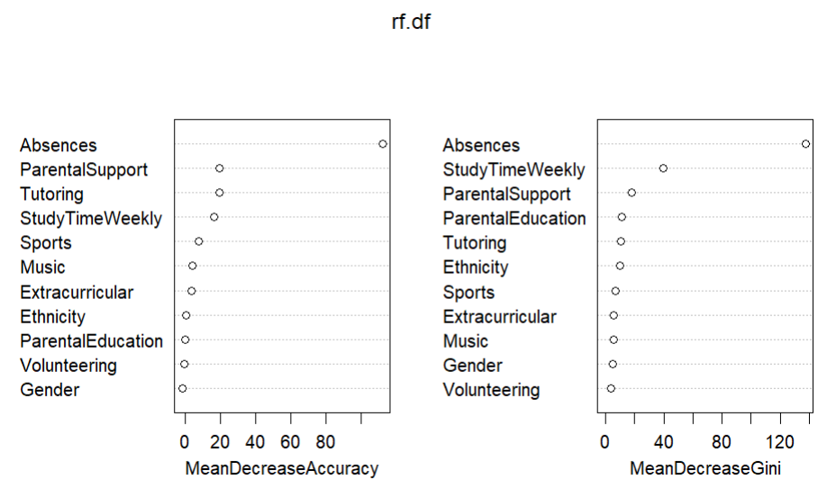
It can be summarized that Absences, StudyTimeWeekly, ParentalSupport and Tutoring are all significant predictors with Absences being the most important.

Model Comparison and Conclusion
The four models were compared on the same train/test split in order to answer the research question which modelling approach performs best for this data set in terms of predictive performance.
The predictive accuracy for each model was calculated, and the results were as follows:
- GLM - 0.9640288
- Deep Learning – 0.955036
- SVM - 0.9559353
- Random Forest - 0.9496403
This indicates that GLM has the best predictive performance however due to class imbalance it is important that the sensitivity and precision is also considered. Sensitivity allows us to see how well each model predicted for the minority class, by identifying from the students who achieved a ‘Good’ GPA the proportion that the model correctly predicted. Precision tells us the proportion of students who actually achieved a ‘Good’ GPA out of those who had been predicted to. The results are as follows:
- GLM: Sensitivity – 0.8784, Precision – 0.8553
- Deep Learning: Sensitivity - 0.7973, Precision – 0.8551
- SVM: Sensitivity – Sensitivity – 0.8581, Precision – 0.8194
- Random Forest – Sensitivity – 0.75, Precision – 0.8538
Despite other models being better at learning non-linear relationships, handling complex numbers, and offering marginal gains in flexibility, robustness and validation of predictor importance, GLM has the highest accuracy, sensitivity and precision and is the most interpretable with Estimates and P-values for each predictor. Therefore, GLM is the best modelling approach for this data set.
Main research question: Determine whether a student’s academic performance can be predicted using data regarding the student’s demographics, study habits, parental involvement and extracurricular activities.
It can be concluded that you can determine whether student’s academic performance can be predicted using data regarding the student’s demographics, study habits, parental involvement and extracurricular activities. Four models were fitted to a data set containing information about such predictors and each four models were able to predict with high accuracy, sensitivity and precision.
Certain predictors were seen to have a greater association with student’s academic performance. The final GLM model was fitted using only StudyTimeWeekly, Absences, Tutoring, ParentalSupport, Extracurricular, Sports and Music, as variable selection found these to be the most important predictors. For the random forest model, the most important predictors were Absences, StudyTimeWeekly, Tutoring and ParentalSupport. The most important predictors for a student’s academic performance are the students study habits, parental involvement and extracurricular activities and while demographics does still play a part in a student’s academic performance it is not as influential as the others.

https://www.findamasters.com/guides/gpa-grade-point-average#:~:text=Not%20all%20graduate%20schools%20in,your%20personal%20statement%20or%20CV.

